**Class Diagram for String class**

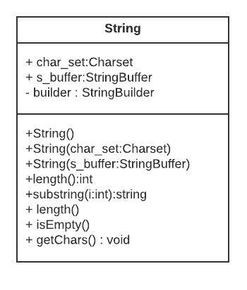

**Class Diagram for PrintStream class**

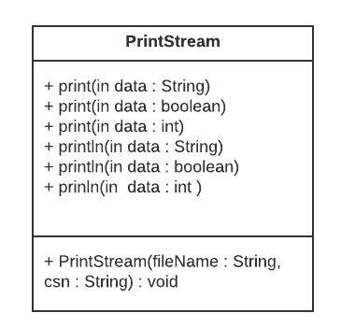

**Class Diagram for System class**

